FIREOPS SYSTEM

IMPLEMENTATION OF SIEM AND INTRUSION DETECTION SYSTEM
USING WAZUH AND SURICATA

Team B
Program: Cybersecurity Internship Project
Focus Area: Network Security Monitoring & Attack Detection
Date: February 21, 2026

Abstract
This project presents the deployment and configuration of a Security Information and Event Management (SIEM) system using Wazuh integrated with Suricata Intrusion Detection System (IDS). The objective was to build a functional security monitoring lab capable of detecting brute force attacks, monitoring file integrity changes, and analyzing security events in real time. The lab environment was implemented using virtual machines in a controlled setting.

Table of Contents
1. Introduction
2. Project Objectives
3. Lab Architecture and Environment Setup
4. Tools and Technologies Used
5. Installation and Configuration Procedures
6. Azure activity for deallocating VM
7. Suricata Integration with Wazuh
8. Brute Force Attack Simulation
9. Alert Monitoring and Log Analysis
10. Security Findings
11. Challenges Encountered
12. Lessons Learned
13. Conclusion

1. Introduction
This project demonstrates the practical implementation of a SIEM system for detecting and analyzing cyber threats within a virtual lab environment. The focus was on real-time log monitoring, intrusion detection, and attack simulation.

2. Project Objectives
- Deploy and configure Wazuh SIEM.
- Install and integrate Suricata IDS.
- Enable File Integrity Monitoring (FIM).
- Simulate brute force attacks using Kali Linux.
- Analyze generated alerts in the Wazuh dashboard.

3. Lab Architecture and Environment Setup
The lab environment consisted of multiple virtual machines including:
- Wazuh Manager
- Ubuntu Agent
- Windows 10 Target Machine
- Kali Linux Attacker Machine
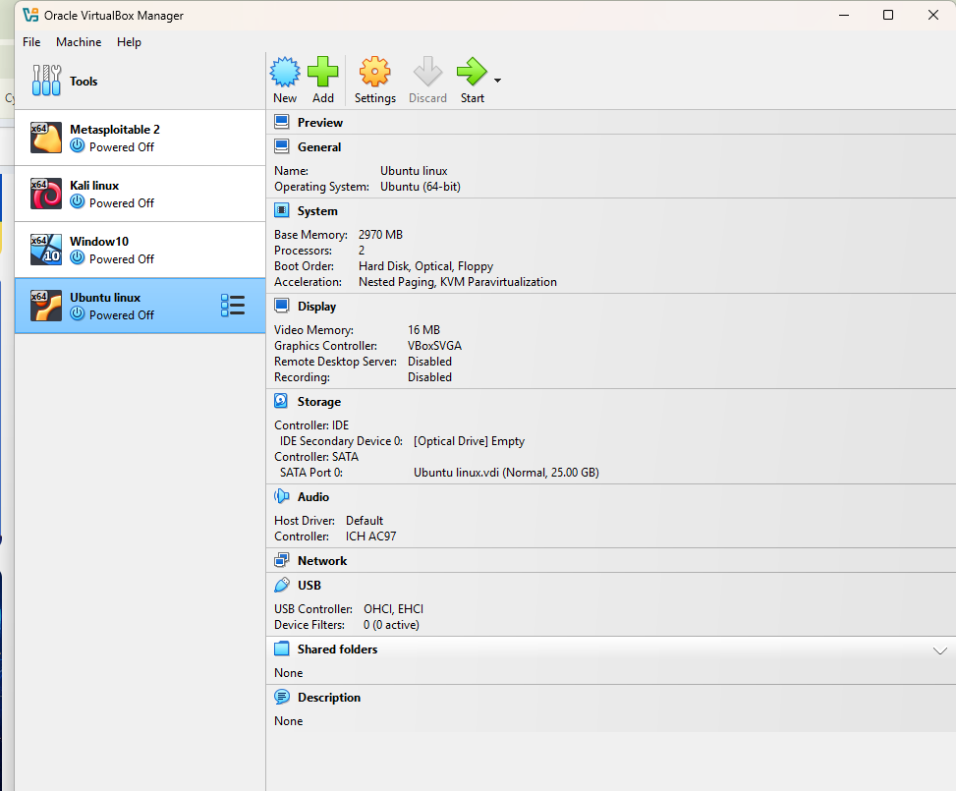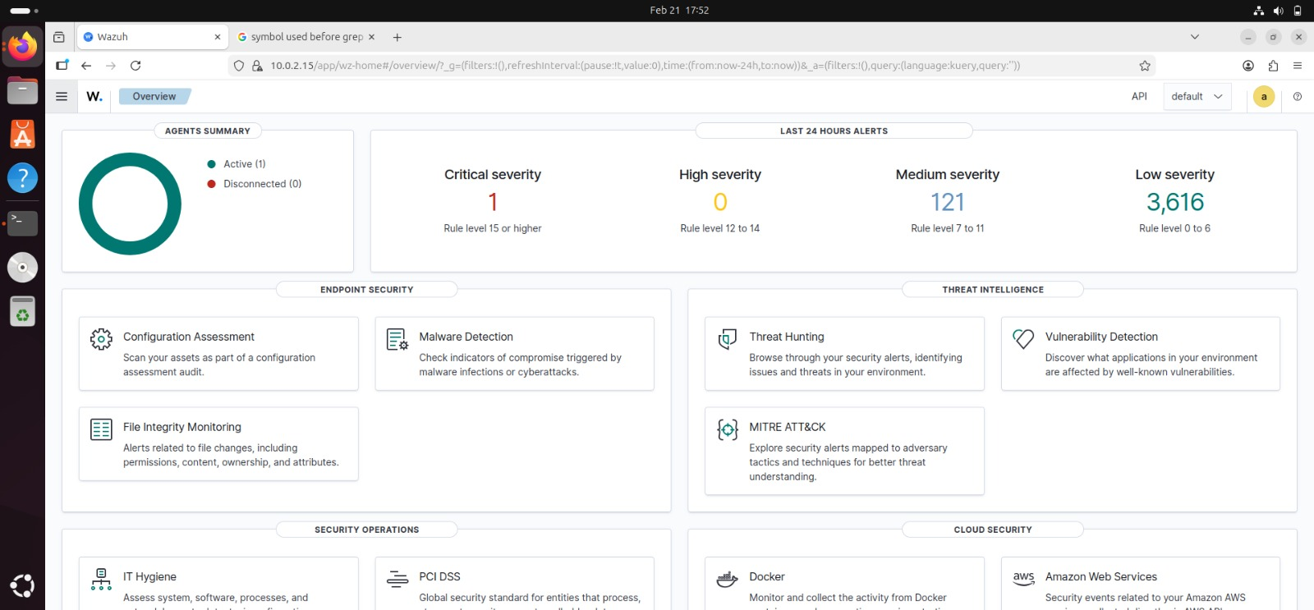

4. Tools and Technologies Used
- VirtualBox
- Wazuh SIEM
- Suricata IDS
- Kali Linux
- Ubuntu Server
- Windows 10

5. Installation and Configuration Procedures
This section documents the commands used to install and configure Wazuh, Suricata, and endpoint agents.

curl -sO https://packages.wazuh.com && sudo bash ./wazuh-install.sh -a

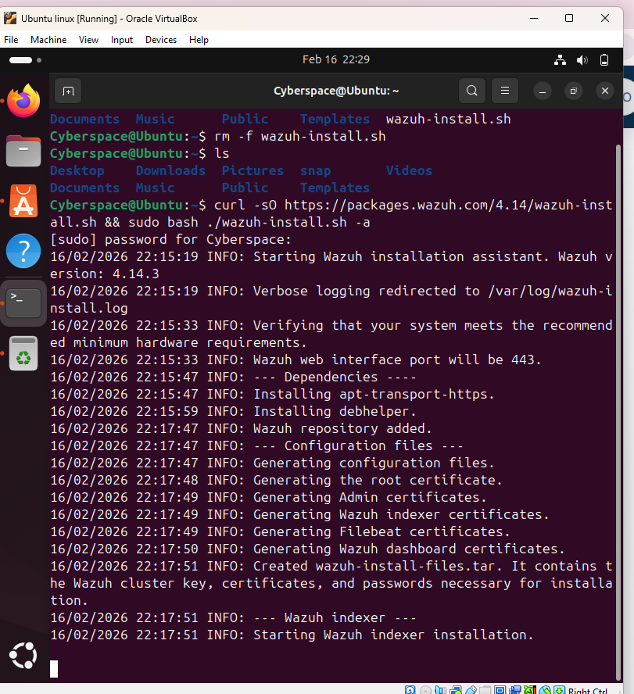

Ubuntu/Debian installation
sudo add-apt-repository ppa:oisf/suricata-stable && sudo apt update && sudo apt install suricata -y

Installing Wazuh Agent
WAZUH_MANAGER="10.0.2.5" apt-get install wazuh-agent
sudo systemctl daemon-reload && sudo systemctl enable wazuh-agent && sudo systemctl
start wazuh-agent

- Azure activity for deallocating VM
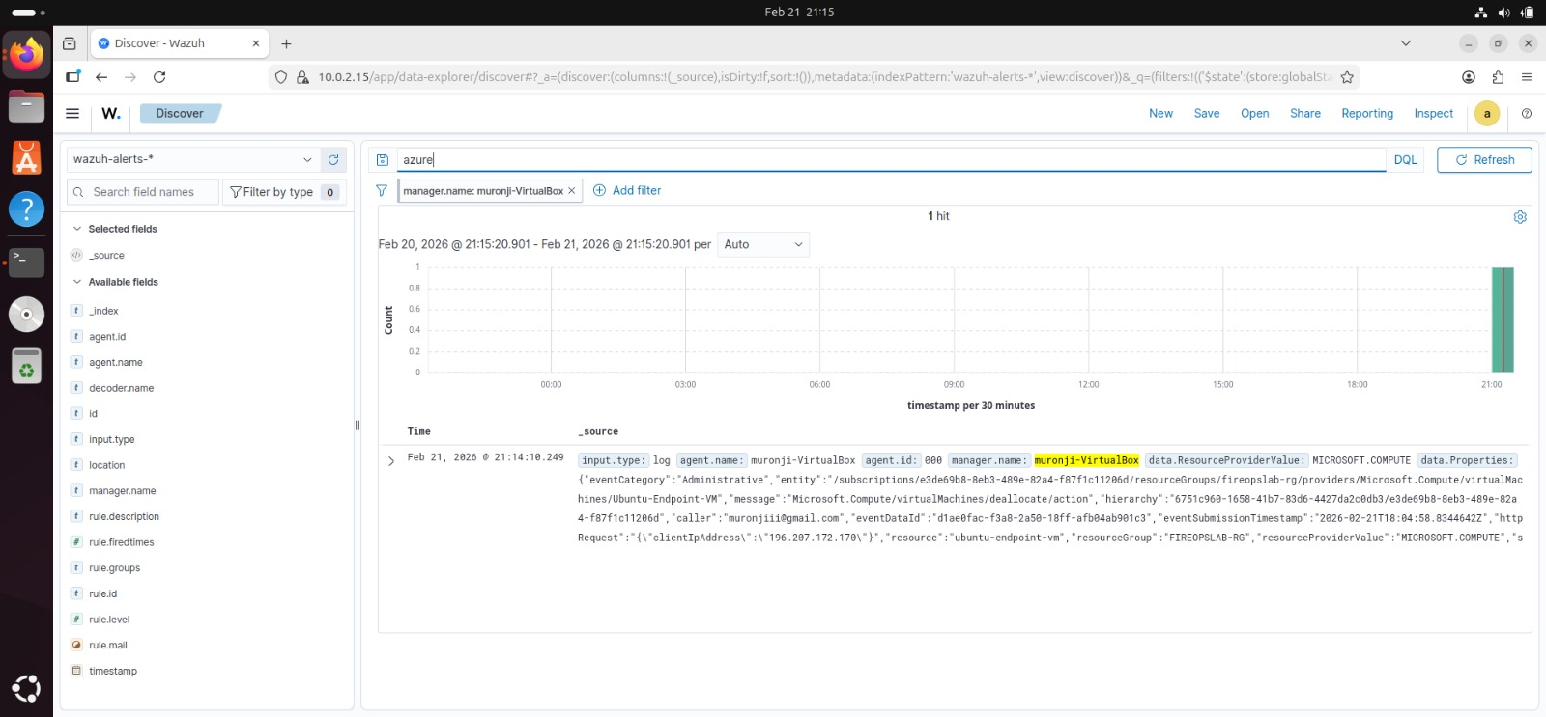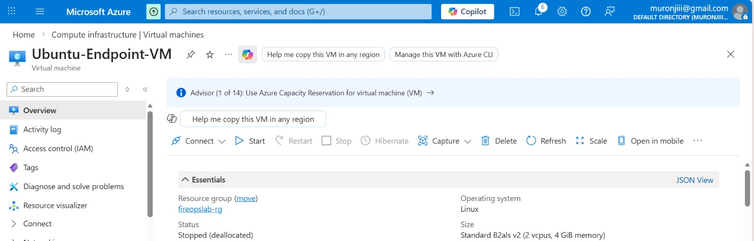

7. Suricata Integration with Wazuh
Suricata was configured to generate logs in JSON format (eve.json), which were integrated into Wazuh for centralized monitoring and alert generation.
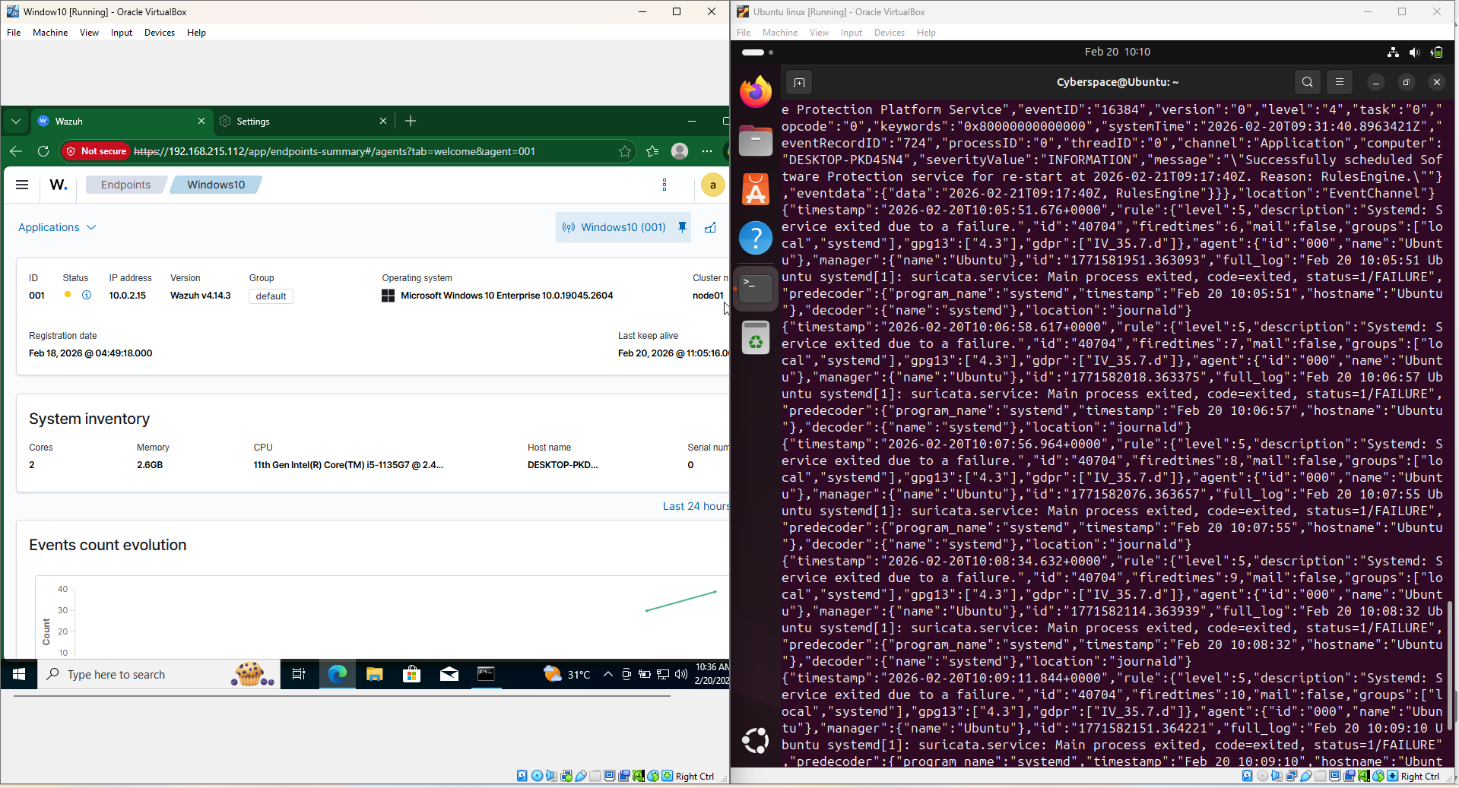

8. Brute Force Attack Simulation
A brute force attack was simulated from Kali Linux targeting the victim machine. The objective was to trigger authentication failure alerts in Wazuh.

9. Alert Monitoring and Log Analysis
Security alerts were analyzed based on severity levels including Critical, High, Medium, and Low. Logs were reviewed to identify attack patterns and suspicious behavior.

10. Security Findings
The SIEM system successfully detected brute force attempts, file integrity violations, and suspicious network traffic patterns.
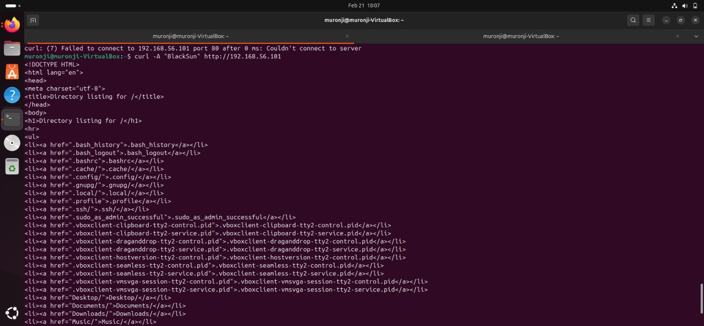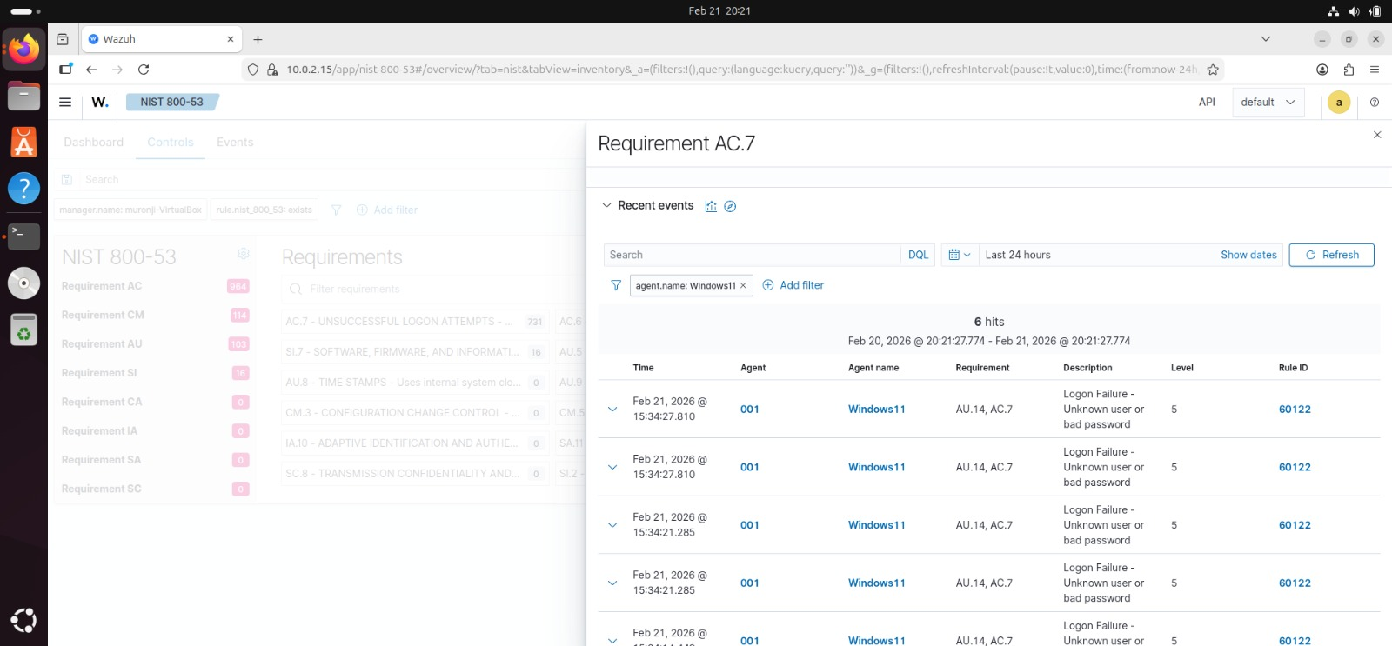

11. Challenges Encountered
- Suricata logs not appearing in the dashboard.
- Agent disconnection troubleshooting.
- JSON log configuration errors but was later configured correctly 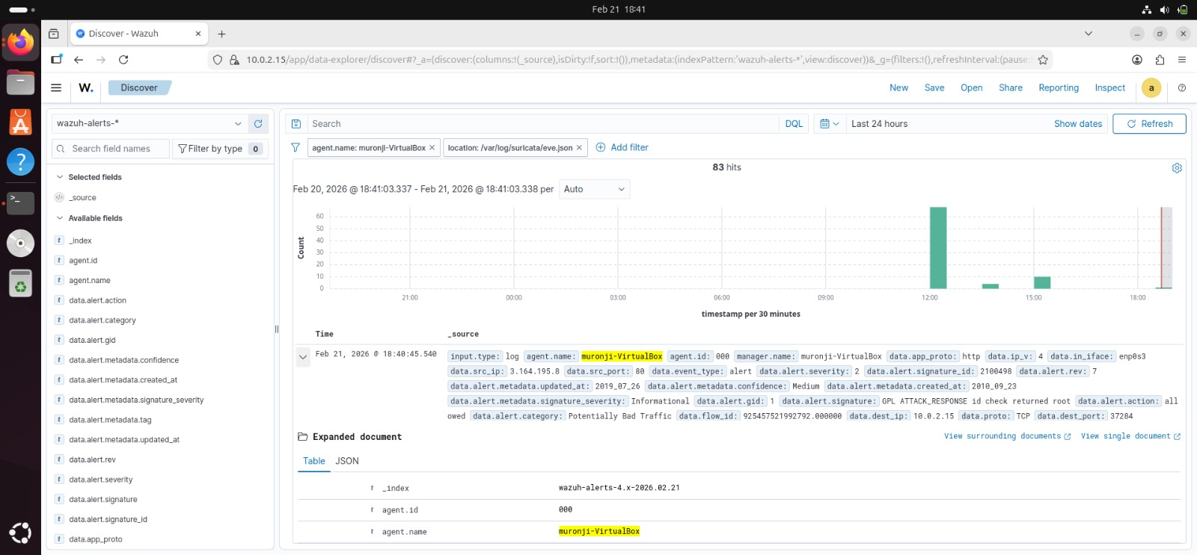

12. Lessons Learned
This project enhanced practical knowledge in SIEM deployment, IDS configuration, log analysis, and incident detection techniques.

13. Conclusion
The successful deployment of Wazuh and Suricata demonstrates the effectiveness of SIEM solutions in monitoring, detecting, and analyzing cybersecurity threats in real time.

